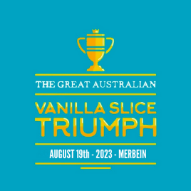
The Great Vanilla Slice Triumph Merbein 2023
Saturday 19th August 2023
87- 89 Commercial St. Merbein Vic. 3505 0418 478 696 greatvanillaslicemerbein@gmail.com

ABN: 55 104 240 106

Company name Click or tap here to enter text.
Company representative (Contact) Click or tap here to enter text.
Title Click or tap here to enter text.
Company address Click or tap here to enter text.
Business phone number Click or tap here to enter text.
Email address Click or tap here to enter text.

We would like to sponsor the Great Vanilla Slice Triumph Merbein 2023(please check the appropriate box)
☐ Premium Platinum - $10,000 + inc GST
☐ Platinum - $10,000 inc GST
☐ Gold - $5,000 inc GST
☐ Silver - $3,000 inc GST
☐ Bronze - $1,000 inc GST

☐ We give you permission to use our logo for the event .
☐ We will let you know when we have all advertising banners ready for pickup prior to event.
☐ And will advise of representative attending the event on the day
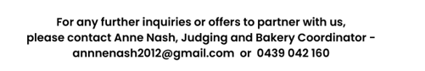
For more information visit - www. https://www.thegreataustralianvanillaslicetriumphmerbein.com

